A PROJECT

ON

**Library Management System**

**Submitted on the partial fulfillment of the requirement of**

**The Degree Of**

**Master of Computer Application**

**(2023 - 2025)**

***Submitted By:-***

**Name: Surya Kanta Dalai**

**Roll no: SF23MCA031**

**Regd no: 30131/2023**

**MCA 3rd Semester**

***Under the guidance of:-***

**Dr. Indrani Kumari Sahu**

**Department of MCA**



**KHALLIKOTE UNITARY UNIVERSITY,**

**BERHAMPUR- 760001**

**CERTIFICATE**

This is to certify that the project report entitled "**Library Management System**" submitted to **Khallikote Unitary University** in partial fulfillment of the requirement for the award of the degree of **Master of Computer Application(MCA), 3rd Semester** is an original work done by **Mr. Surya Kanta Dalai** bearing **Regd No: 30131/2023** & **Roll no: SF23MCA031.**

This project is authentic and genuine work done by the student and has not been submitted to the University or to any other University/Institute for the fulfilment of the requirement of any course of study.

Signature of Guide

**DECLARATION**

I **Surya Kanta Dalai** student of **Khallikote Unitary University**, has developed this project "**Library Management System**" using **HTML, CSS, Java Script, PHP & MYSQL** in the partial fulfilment of the requirement for the award of **Master Of Computer Application** and have not copied or depicted from any internal or external source. If at any subsequent time it is found that project is taken from any other source it may be scratched or cancelled.

Signature of the Student

Date:

**ACKNOWLEDGEMENT**

I am giving tips of great pleasure to the outstanding and inevitable personalities who helped me a lot in completing and submitting the project. I would like to thank our **HOD** sir **Dr. Deepak Kumar Mishra** for allowing me to do this project. I am thankful to my guide **Dr. Indrani Kumari Sahu**, **Department of MCA, Khallikote Unitary University** for her valuable guidance.

Finally, I wish to thank towards my parents, friends for their valuable advice, encouragement and inspiration during the completion of my project work.

**Mr. Surya Kanta Dalai**

**Roll No: SF23MCA031**

**TABEL OF CONTENTS**

**Serial no Topic Page no**

1. **INTRODUCTION 1-1**
   * 1. **BACKGROUND 1-1**
     2. **OBJECTIVES 1-1**
     3. **PURPOSE, SCOPE 1-2**
2. **REQUIREMENTS AND ANALYSIS 2-2**
   * 1. **PROBLEM DEFINITION 2-2**
     2. **REQUIRMENTS SPECIFICATION 2-3**
     3. **SOFTWARE AND HARDWARE REQUIRMENTS 3-3**
3. **SYSTEM DESIGN 3-3**
   * 1. **BASIC MODULES 3-3**
     2. **DATA DESIGN 3-4**
        1. **LOGIC DIAGRAM 4-5**
        2. **DATA STRUCTURES 5-5**
        3. **ALGORITHMS DESIGN 5-5**
     3. **CODING & SCREEN SHOT 6-76**
4. **IMPLIMENTATION AND TESTING 76-76**
   * 1. **IMPLIMENTATION APPROACHES 76-77**
     2. **TESTING APPROACH 77-77**
        1. **UNIT TESTING 77-77**
        2. **INTIGREATED TESTING 78-78**
5. **RESULT AND DISCUSSION 78-78**
6. **CONCLUSION 79-79**
   * 1. **LIMITATIONS OF THE Project 79-79**
     2. **FUTURE SCOPE OF THE PROJECT 79-80**
7. **REFERENCES 80-80**
8. **GLOSSARY 80-80**
9. **INTRODUCTION**

A **Library Management System (LMS)** is a comprehensive software solution designed to automate and streamline library operations, making it easier for librarians, administrators, and users to manage books, track borrowing activities, and organize digital and physical resources efficiently. It plays a crucial role in modernizing traditional libraries by reducing manual work, improving accessibility, and ensuring smooth transactions between users and library staff.

With the rapid advancement in **technology and digital transformation**, libraries across schools, colleges, universities, and public institutions are shifting towards automated LMS solutions. The primary goal of an LMS is to provide a **centralized platform** where users can **search for books, borrow and return books, reserve materials, and keep track of their reading history** while allowing administrators to **manage inventory, handle fines, and generate reports** with ease.

* + 1. **BACKGROUND**

Libraries play a crucial role in knowledge dissemination, serving students, researchers, and the general public. Traditionally, library management relied on physical record books and manual entry systems, which often resulted in errors, misplaced books, and inefficiencies.

With advancements in technology, digital solutions have emerged to address these challenges. A Library Management System automates key operations such as book cataloging, user registration, book issuance, returns, and fine calculations. It also provides a centralized database that enhances accessibility and improves record management.

* + 1. **OBJECTIVES**

The key objectives of the Library Management System are:

* **Automation of Library Operations**: Replace manual record keeping with an efficient digital system.
* **Easy Book Management**: Allow librarians to add, update, search, and remove books seamlessly.
* **User-Friendly Borrowing System**: Enable users to check book availability, issue books, and return them with ease.
* **Efficient User Management**: Maintain details of library users, including students, and staff.
* **Report Generation**: Provide insights into book circulation, user activity, and overdue books.
  + 1. **PURPOSE, SCOPE**

**Purpose of the System**

The primary objective of the Library Management System is to enhance the efficiency of library management by:

* **Automating** the process of book issuance, return, and tracking.
* **Managing** user information, including students, faculty, and staff.
* **Reducing errors and improving accuracy** in maintaining records.
* **Providing reports** on book availability, overdue books, and user activity.
* **Improve efficiency** in handling books and user records.
* **Minimize human errors** in tracking book transactions.
* **Enhance the user experience** with an easy-to-use interface.
* **Save time and effort** for both library staff and users.

**Scope of the System**

The system will be developed as a web-based or desktop application, depending on the implementation. It will include:

* **User Authentication:** Admins, librarians, and users with different access levels.
* **Book Management:** Adding, updating, searching, and deleting book records.
* **User Management:** Maintaining user details and borrowing history.
* **Book Issuing & Returns:** Tracking due dates and generating fines if applicable.
* **Library Staff/Admins:** Managing books, users, and transactions.
* **Registered Users:** Searching for books, borrowing, and returning books.
* **Database Management:** A structured system for storing and retrieving book and user information.

1. **REQUIREMENTS AND ANALYSIS**

The Library Management System (LMS) aims to improve the efficiency and accuracy of managing library resources. This section outlines the system's requirements, including problem definition, functional and non-functional requirements, and necessary software and hardware specifications.

* + 1. **PROBLEM DEFINITION**

**Existing Problems**

Traditional library management methods involve manual record keeping, which leads to several challenges:

* **Time-Consuming Processes**: Searching for books, issuing, and returning them manually takes a lot of time.
* **Errors in Record-Keeping**: Manual data entry increases the chances of errors in book availability and user records.
* **Difficulty in Tracking Books**: Books may be misplaced, and tracking overdue books is challenging.
* **Lack of Automation**: There is no automated system for calculating fines, sending due-date notifications, or generating reports.

**Proposed Solution**

The Library Management System will automate these operations, ensuring:

* Easy book management with a searchable catalog.
* Automated book issuance and return tracking.
* Efficient user management with borrowing history.
* Fine calculation and due-date reminders.
* Secure access for different user roles (admin, and user).
  + 1. **REQUIRMENTS SPECIFICATION**

**Functional Requirements**

* **User Authentication**: Login for admins, and users.
* **Book Management**: Add, update, and delete books.
* **User Management**: Maintain user records and borrowing history.
* **Book Issuance & Return**: Track issued books, due dates, and fine calculations.
* **Reports & Statistics**: Generate reports on book transactions and user activities.

**Non-Functional Requirements**

* **Scalability**: The system should support multiple users and large book databases.
* **Security**: Role-based access control for admins, and users.
* **Performance**: The system should process requests quickly.
* **Usability**: User-friendly interface with easy navigation.
* **Reliability**: The system should work without failure and ensure data integrity.
  + 1. **SOFTWARE AND HARDWARE REQUIRMENTS**

**Software Requirements**

* **Operating System**: Windows / Linux / macOS
* **Database Management System**: MySQL
* **Backend Technologies**: PHP
* **Frontend Technologies**: HTML, CSS, JavaScript
* **Development Tools**: VS Code

**Hardware Requirements**

* **Processor: Intel i5 or higher / AMD equivalent**
* **RAM: Minimum 4GB (Recommended: 8GB or more)**
* **Storage: At least 50GB of free space (SSD recommended)**
* **Internet Connectivity: Required for web-based applications**
* **Display: Minimum resolution of 1366x768**

1. **SYSTEM DESIGN**

The System Design phase focuses on defining the architecture, modules, data structures, and algorithms that will be used to develop the Library Management System. This section provides an overview of the system’s design approach and components.

* + 1. **BASIC MODULES**

The Library Management System consists of several interconnected modules that handle different functionalities:

**User Management Module**

* Handles user registration, login, and role-based access control.
* Maintains user profile.

**Book Management Module**

* Allows adding, updating, searching, and deleting book records.
* Stores book details like ISBN, title, author, publisher, and category.

**Book Issuance & Return Module**

* Handles book borrowing and returning process.
* Tracks due dates and calculates fines for overdue books.

**Search & Filter Module**

* Enables users to search for books by title, author, category, or availability.

**Fine Calculation Module**

* Automatically calculates fines for overdue books.
* Generates payment reports for unpaid fines.

**Notification & Reporting Module**

* Sends due-date reminders and overdue notifications via email/SMS.
* Generates reports on book circulation and user activity.
  + 1. **DATA DESIGN**

The data design includes structuring the database, defining relationships, and implementing efficient data handling.

* + - 1. **LOGIC DIAGRAM**

**Data Flow Diagram**

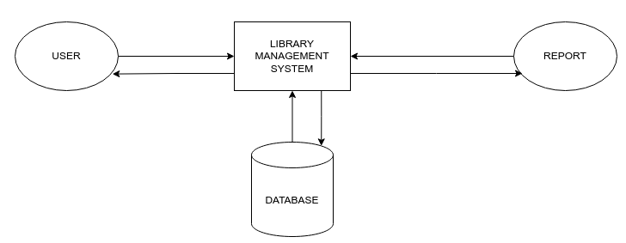

**ER Model**

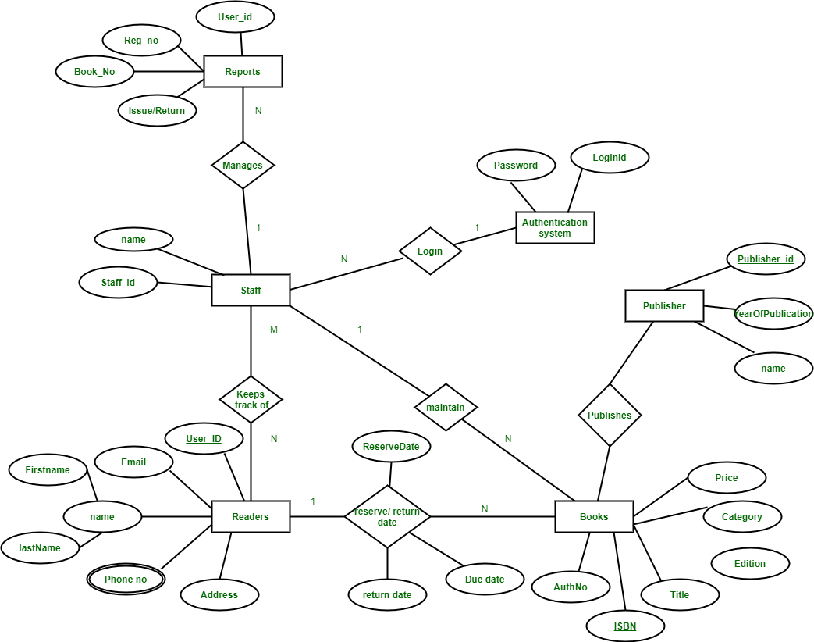

**Use Case Diagram**

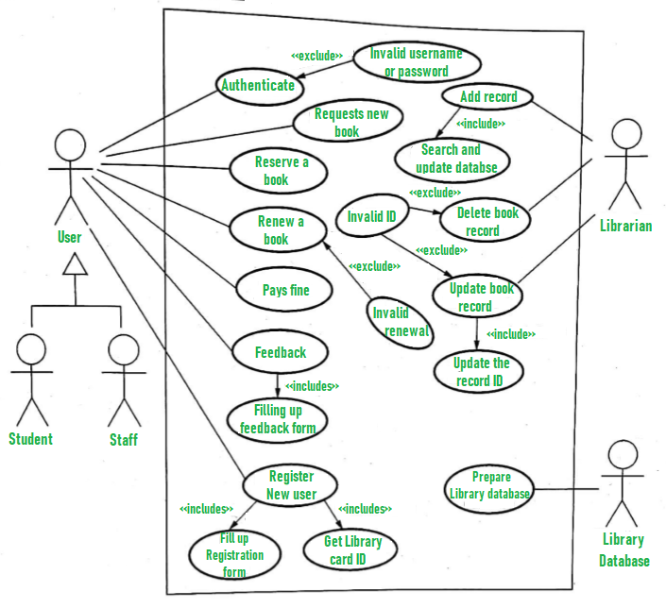

**Activity Diagram**

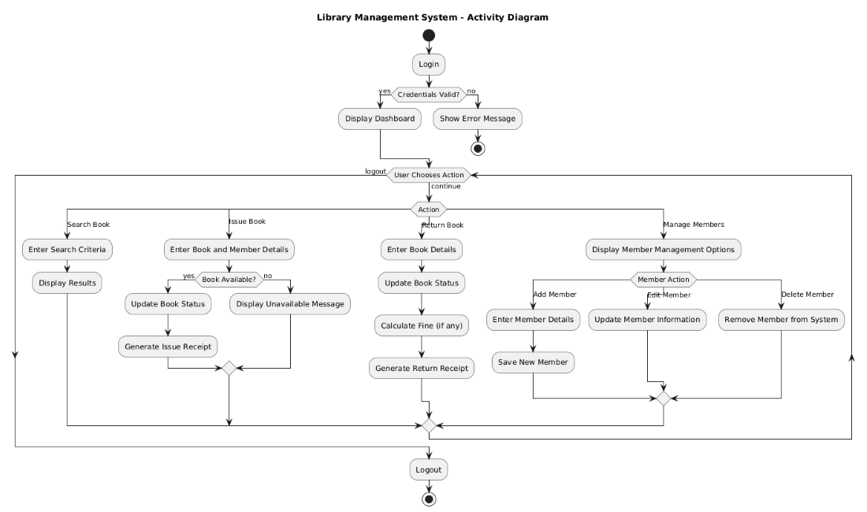

**Class Diagram**

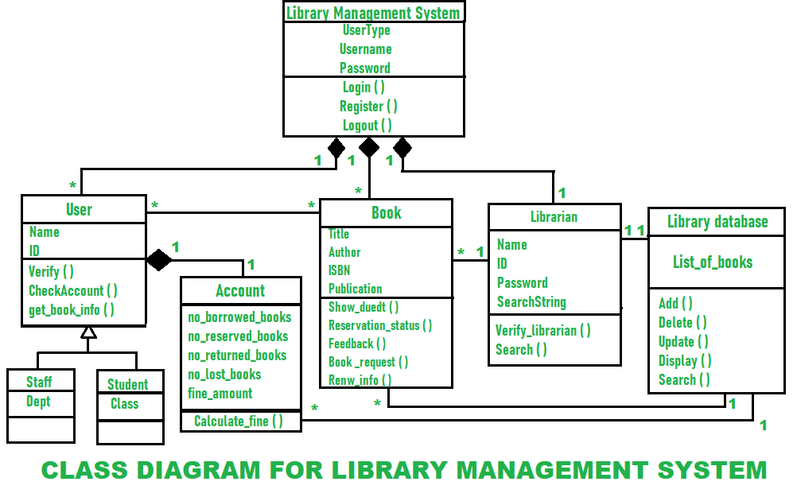

* + - 1. **DATA STRUCTURES**

The Library Management System will use the following data structures:

**Tables in Relational Database (SQL Example)**

* Users Table: Stores user details (user_id, name, email, and address).
* Books Table: Stores book details (book_id, title, author, ISBN, availability).
* Transactions Table: Tracks issued books (transaction_id, user_id, book_id, issue_date, return_date, fine)
  + - 1. **ALGORITHMS DESIGN**

The following key algorithms will be implemented in the Library Management System:

**Book Search Algorithm**

* Input: Book title, author, or ISBN.
* Process: Use a hash map or SQL query to search for matching books.
* Output: List of books matching the search criteria.

**Book Issuance Algorithm**

* Input: User ID, Book ID.
* Process: Check availability → Issue book → Update records.
* Output: Success or failure message.

**Fine Calculation Algorithm**

* Input: Return date, due date.
* Process: Calculate the number of overdue days and multiply by the fine rate.
* Output: Fine amount.

**Due-Date Notification Algorithm**

* Input: Current date, due date of books.
* Process: Compare dates and notify users if books are overdue.
* Output: Send email/SMS notification.
  + 1. **CODING & SCREEN SHOT**

**index.php**

<!DOCTYPE html>

<html lang="en">

<head>

    <title>Surya City Library</title>

    <meta charset="UTF-8">

    <meta name="viewport" content="width=device-width, initial-scale=1.0">

    <link rel="icon" href="favicon.png" type="image/x-icon">

    <link rel="stylesheet" href="library.css">

</head>

<body>

    <header>

        <div class="logo">

            <a href="index.php">

                <img class="logo" src="favicon.png" alt="Library Logo">

            </a>

        </div>

        <nav>

            <ul>

                <li><a href="index.php">Home</a></li>

                <li><a href="Privacy.php" class="nav-link">Privacy</a></li>

                <li><a href="About.php" class="nav-link">About</a></li>

                <li><a href="Contact.php" class="nav-link">Contact</a></li>

                <li>

                    <button class="btn-primary">Login</button>

                    <div class="dropdown">

                        <a href="Student_Login.php">Student</a>

                        <a href="Librarian_Login.php">Librarian</a>

                    </div>

                </li>

            </ul>

        </nav>

    </header>

    <section class="hero">

        <div class="hero-content">

            <h1>Book Library</h1>

            <p class="content">Book libraries are collections of different books that are available for reading or borrowing. This library makes easier for readers to access and explore literature and educational resources.</p>

        </div>

        <div class="hero-image">

            <img src="Library Hero.jpg" alt="Library Hero image">

        </div>

    </section>

    <footer>

        <p>Copyright &copy;2025 : <b>Surya City Library</b></p>

        <nav>

            <ul>

                <li><a href="https://www.facebook.com/suryacitylibrary" target="_blank">Facebook</a></li>

                <li><a href="https://www.instagram.com/suryacitylibrary" target="_blank">Instagram</a></li>

                <li><a href="https://wa.me/917788873416" target="_blank">Whatsapp</a></li>

                <li><a href="mailto:suryacitylibrary@gmail.com" target="_blank">Email</a></li>

                <li><a href="#top" class="btn-primary">Top</a></li>

            </ul>

        </nav>

    </footer>

</body>

</html>

**Student_Login.php**

<?php

    session_start();

?>

<!DOCTYPE html>

<html lang="en">

<head>

    <meta charset="UTF-8">

    <meta name="viewport" content="width=device-width, initial-scale=1.0">

    <title>Student Login - Surya City Library</title>

    <link rel="icon" href="favicon.png" type="image/x-icon">

    <link rel="stylesheet" href="library.css">

</head>

<body>

    <header>

        <div class="logo">

            <a href="index.php">

                <img class="logo" src="favicon.png" alt="Library Logo">

            </a>

        </div>

        <nav>

            <ul>

                <li><a href="index.php">Home</a></li>

                <li><a href="Privacy.php" class="nav-link">Privacy</a></li>

                <li><a href="About.php" class="nav-link">About</a></li>

                <li><a href="Contact.php" class="nav-link">Contact</a></li>

                <li>

                    <button class="btn-primary">Login</button>

                    <div class="dropdown">

                        <a href="Student_Login.php">Student</a>

                        <a href="Librarian_Login.php">Librarian</a>

                    </div>

                </li>

            </ul>

        </nav>

    </header>

    <div class="heading">

        <h1><b>Student Login</b></h1>

    </div>

    <form action="" method="post">

        <div class="container">

            <label for="email"><b>Email ID :</label>

            <input type="email" placeholder="Enter email ID" name="email" required>

            <label for="password">Password :</label>

            <input placeholder="Enter Password" type="password" id="password" name="password" required

                pattern="(?=.*[a-z])(?=.*[A-Z])(?=.*\d)(?=.*[@$!%*?&])[A-Za-z\d@$!%*?&]{8,}"

                title="Password must contain at least 8 characters, including uppercase, lowercase, number and special character.">

            <button type="submit" name="submit">Login</button>

            <button type="reset" class="reset">Reset</button>

            <span class="nsr"><a href="student_register.php">New Student Register</a></span>

        </div>

    </form>

    <?php

        if (isset($_POST['submit'])) {

            $connection = mysqli_connect("localhost", "root", "tiger", "lms");

            if (!$connection) {

                die("Database Connection Failed: " . mysqli_connect_error());

            }

            $email = $_POST['email'];

            $password = $_POST['password'];

            $query = "SELECT * FROM users WHERE email = ?";

            $stmt = mysqli_prepare($connection, $query);

            mysqli_stmt_bind_param($stmt, "s", $email);

            mysqli_stmt_execute($stmt);

            $result = mysqli_stmt_get_result($stmt);

            if ($row = mysqli_fetch_assoc($result)) {

                if ($row['password'] === $password) {

                    $_SESSION['name'] = $row['name'];

                    $_SESSION['email'] = $row['email'];

                    $_SESSION['id'] = $row['id'];

                    ob_clean();

                    header("Location: student_dashboard.php");

                    exit();

                } else {

                    echo "<p style='color: red; text-align: center;'>Wrong Password !!</p>";

                }

            } else {

                echo "<p style='color: red; text-align: center;'>User not found !!</p>";

            }

            mysqli_stmt_close($stmt);

            mysqli_close($connection);

        }

    ?>

    <footer>

        <p>Copyright &copy;2025 : <b>Surya City Library</b></p>

        <nav>

            <ul>

                <li><a href="https://www.facebook.com/suryacitylibrary" target="_blank">Facebook</a></li>

                <li><a href="https://www.instagram.com/suryacitylibrary" target="_blank">Instagram</a></li>

                <li><a href="https://wa.me/917788873416" target="_blank">Whatsapp</a></li>

                <li><a href="mailto:suryacitylibrary@gmail.com" target="_blank">Email</a></li>

                <li><a href="#top" class="btn-primary">Top</a></li>

            </ul>

        </nav>

    </footer>

</body>

</html>

**student_register.php**

<!DOCTYPE html>

<html>

<head>

<meta charset="UTF-8">

    <meta name="viewport" content="width=device-width, initial-scale=1.0">

    <title>New student register - Surya City Library</title>

    <link rel="icon" href="favicon.png" type="image/x-icon">

    <link rel="stylesheet" href="library.css">

</head>

<body>

    <header>

        <div class="logo">

            <a href="index.php">

                <img class="logo" src="favicon.png" alt="Library Logo">

            </a>

        </div>

        <nav>

            <ul>

                <li><a href="index.php">Home</a></li>

                <li><a href="Privacy.php" class="nav-link">Privacy</a></li>

                <li><a href="About.php" class="nav-link">About</a></li>

                <li><a href="Contact.php" class="nav-link">Contact</a></li>

                <li>

                    <button class="btn-primary">Login</button>

                    <div class="dropdown">

                        <a href="Student_Login.php">Student</a>

                        <a href="Librarian_Login.php">Librarian</a>

                    </div>

                </li>

            </ul>

        </nav>

    </header>

    <div class="heading">

        <h1><b>Student Registration Form</b></h1>

    </div>

    <form action="" method="post">

        <div class="container">

            <label for="name">Full Name:</label>

            <input type="text" name="name" placeholder="Enter your name"required>

            <label for="email">Email ID:</label>

            <input type="email" name="email" placeholder="Enter your email ID" required>

            <label for="password">Password:</label>

            <input placeholder="Enter Password" type="password" name="password" required

                pattern="(?=.*[a-z])(?=.*[A-Z])(?=.*\d)(?=.*[@$!%*?&])[A-Za-z\d@$!%*?&]{8,}"

                title="Password must contain at least 8 characters, including uppercase, lowercase, number and special character.">

            <label for="mobile">Mobile:</label>

            <input type="tel" name="mobile" placeholder="Enter your mobile no" pattern="[6-9][0-9]{9}" required>

            <label for="address">Address:</label>

            <input type="address" name="address" placeholder="Enter your full address" required>

            <button type="submit" class="btn-primary">Register</button>

        </div>

    </form>

<?php

$connection = mysqli_connect("localhost", "root", "tiger", "lms");

if (!$connection) {

    die("Connection failed: " . mysqli_connect_error());

}

if ($_SERVER["REQUEST_METHOD"] == "POST") {

    $name = isset($_POST['name']) ? mysqli_real_escape_string($connection, $_POST['name']) : '';

    $email = isset($_POST['email']) ? mysqli_real_escape_string($connection, $_POST['email']) : '';

    $password = isset($_POST['password']) ? mysqli_real_escape_string($connection, $_POST['password']) : '';

    $mobile = isset($_POST['mobile']) ? mysqli_real_escape_string($connection, $_POST['mobile']) : '';

    $address = isset($_POST['address']) ? mysqli_real_escape_string($connection, $_POST['address']) : '';

    if (empty($name) || empty($email) || empty($password) || empty($mobile) || empty($address)) {

        echo "<script>alert('Error: All fields are required!'); window.location.href='student_register.php';</script>";

        exit();

    }

    $email_check_query = "SELECT * FROM users WHERE email = '$email'";

    $result = mysqli_query($connection, $email_check_query);

    if (mysqli_num_rows($result) > 0) {

        echo "<script>alert('Error: Email already registered. Try another email!'); window.location.href='student_register.php';</script>";

    } else {

        $query = "INSERT INTO users (name, email, password, mobile, address) VALUES ('$name', '$email', '$password', '$mobile', '$address')";

        if (mysqli_query($connection, $query)) {

            echo "<script>alert('Registration successful! You may log in now.'); window.location.href='Student_Login.php';</script>";

        } else {

            echo "<script>alert('Error: Unable to register. Try again later.'); window.location.href='student_register.php';</script>";

        }

    }

}

mysqli_close($connection);

?>

    <footer>

        <p>Copyright &copy;2025 : <b>Surya City Library</b></p>

        <nav>

            <ul>

                <li><a href="https://www.facebook.com/suryacitylibrary" target="_blank">Facebook</a></li>

                <li><a href="https://www.instagram.com/suryacitylibrary" target="_blank">Instagram</a></li>

                <li><a href="https://wa.me/917788873416" target="_blank">Whatsapp</a></li>

                <li><a href="mailto:suryacitylibrary@gmail.com" target="_blank">Email</a></li>

                <li><a href="#top" class="btn-primary">Top</a></li>

            </ul>

        </nav>

    </footer>

</body>

</html>

**student_dashboard.php**

<?php

    session_start();

    function get_user_issue_book_count(){

        $connection = mysqli_connect("localhost","root","tiger");

        $db = mysqli_select_db($connection,"lms");

        $user_issue_book_count = 0;

        $query = "select count(*) as user_issue_book_count from issued_books where student_id = $_SESSION[id]";

        $query_run = mysqli_query($connection,$query);

        while ($row = mysqli_fetch_assoc($query_run)){

            $user_issue_book_count = $row['user_issue_book_count'];

        }

        return($user_issue_book_count);

    }

?>

<!DOCTYPE html>

<html>

<head>

    <meta charset="UTF-8">

    <meta name="viewport" content="width=device-width, initial-scale=1.0">

    <title>Student dashboard - Surya City Library</title>

    <link rel="icon" href="favicon.png" type="image/x-icon">

    <link rel="stylesheet" href="login_library.css">

</head>

<body>

    <header>

        <div class="logo">

            <a href="student_dashboard.php">

                <img class="logo" src="favicon.png" alt="Library Logo">

            </a>

        </div>

        <nav>

            <ul class="nav-links">

                <li>Email: <?php echo $_SESSION['email']; ?></li>

                <li class="dropdown">

                    <button class="dropbtn">My Profile</button>

                    <div class="dropdown-content">

                        <a href="student_view_profile.php">View Profile</a>

                        <a href="student_edit_profile.php">Edit Profile</a>

                    </div>

                </li>

                <li>

                    <a href="logout.php" class="btn-primary">Logout</a>

                </li>

            </ul>

        </nav>

    </header>

    <div class="heading">

        <h1><b>Welcome <?php echo explode(' ', $_SESSION['name'])[0]; ?>'s Dashboard</b></h1>

    </div>

    <div class="col-md-3" style="margin: 25px">

            <div class="card bg-light" style="width: 300px">

                <div class="card-header">Book Issued</div>

                <div class="card-body">

                    <p class="card-text">No of book issued: <?php echo get_user_issue_book_count();?></p>

                    <a class="btn btn-success" href="student_view_issued_book.php">View Issued Books</a>

                </div>

            </div>

        </div>

    <footer>

        <p>Copyright &copy;2025 : <b>Surya City Library</b></p>

        <nav>

            <ul>

                <li><a href="https://www.facebook.com/suryacitylibrary" target="_blank">Facebook</a></li>

                <li><a href="https://www.instagram.com/suryacitylibrary" target="_blank">Instagram</a></li>

                <li><a href="https://wa.me/917788873416" target="_blank">Whatsapp</a></li>

                <li><a href="mailto:suryacitylibrary@gmail.com" target="_blank">Email</a></li>

                <li><a href="#top" class="btn-primary">Top</a></li>

            </ul>

        </nav>

    </footer>

</body>

</html>

**student_view_issued_book.php**

<?php

    session_start();

?>

<!DOCTYPE html>

<html>

<head>

    <meta charset="UTF-8">

    <meta name="viewport" content="width=device-width, initial-scale=1.0">

    <title>Student Issued Bookes</title>

    <link rel="icon" href="favicon.png" type="image/x-icon">

    <link rel="stylesheet" href="login_library.css">

</head>

<body>

    <header>

        <div class="logo">

            <a href="student_dashboard.php">

                <img class="logo" src="favicon.png" alt="Library Logo">

            </a>

        </div>

        <nav>

            <ul class="nav-links">

                <li>Email: <?php echo $_SESSION['email']; ?></li>

                <li class="dropdown">

                    <button class="dropbtn">My Profile</button>

                    <div class="dropdown-content">

                        <a href="student_view_profile.php">View Profile</a>

                        <a href="student_edit_profile.php">Edit Profile</a>

                    </div>

                </li>

                <li>

                    <a href="logout.php" class="btn-primary">Logout</a>

                </li>

            </ul>

        </nav>

    </header>

    <div class="heading">

        <h1><b>Welcome <?php echo explode(' ', $_SESSION['name'])[0]; ?>'s Dashboard</b></h1>

    </div>

    <center>

        <h3>Issued Bookes</h3>

    </center>

    <form>

        <table class="table-bordered" width="900px" style="text-align: center">

            <tr>

                <th>Name</th>

                <th>Author</th>

                <th>Number</th>

            </tr>

            <?php

                $connection = mysqli_connect("localhost", "root", "tiger", "lms");

                if (!$connection) {

                    die("Connection failed: " . mysqli_connect_error());

                }

                $query = "select book_name,author_name,book_no from issued_books where student_id = $_SESSION[id] and status = 1";

                $query_run = mysqli_query($connection,$query);

                while ($row = mysqli_fetch_assoc($query_run)){

            ?>

            <tr>

                <td><?php echo $row['book_name'];?></td>

                <td><?php echo $row['author_name'];?></td>

                <td><?php echo $row['book_no'];?></td>

            </tr>

            <?php

                    }

            ?>

        </table>

    </form>

    <footer>

        <p>Copyright &copy;2025 : <b>Surya City Library</b></p>

        <nav>

            <ul>

                <li><a href="https://www.facebook.com/suryacitylibrary" target="_blank">Facebook</a></li>

                <li><a href="https://www.instagram.com/suryacitylibrary" target="_blank">Instagram</a></li>

                <li><a href="https://wa.me/917788873416" target="_blank">Whatsapp</a></li>

                <li><a href="mailto:suryacitylibrary@gmail.com" target="_blank">Email</a></li>

                <li><a href="#top" class="btn-primary">Top</a></li>

            </ul>

        </nav>

    </footer>

</body>

</html>

**Librarian_Login.php**

<?php

    session_start();

?>

<!DOCTYPE html>

<html lang="en">

<head>

    <meta charset="UTF-8">

    <meta name="viewport" content="width=device-width, initial-scale=1.0">

    <title>Librarian Login - Surya City Library</title>

    <link rel="icon" href="favicon.png" type="image/x-icon">

    <link rel="stylesheet" href="library.css">

</head>

<body>

    <header>

        <div class="logo">

            <a href="index.php">

                <img class="logo" src="favicon.png" alt="Library Logo">

            </a>

        </div>

        <nav>

            <ul>

                <li><a href="index.php">Home</a></li>

                <li><a href="Privacy.php" class="nav-link">Privacy</a></li>

                <li><a href="About.php" class="nav-link">About</a></li>

                <li><a href="Contact.php" class="nav-link">Contact</a></li>

                <li><button class="btn-primary">Login</button>

                    <div class="dropdown">

                        <a href="Student_Login.php">Student</a>

                        <a href="Librarian_Login.php">Librarian</a>

                    </div>

                </li>

            </ul>

        </nav>

    </header>

    <div class="heading">

        <h1><b>Librarian Login</b></h1>

    </div>

    <form action="" method="post">

        <div class="container">

            <label for="email"><b>Email ID :</label>

            <input type="email" placeholder="Enter email ID" name="email" required>

            <label for="password">Password :</label>

            <input placeholder="Enter Password" type="password" id="password" name="password" required

                pattern="(?=.*[a-z])(?=.*[A-Z])(?=.*\d)(?=.*[@$!%*?&])[A-Za-z\d@$!%*?&]{8,}"

                title="Password must contain at least 8 characters, including uppercase, lowercase, number and special character.">

            <button type="submit" name="submit">Login</button>

            <button type="reset" class="reset">Reset</button>

        </div>

    </form>

    <?php

        if (isset($_POST['submit'])) {

            $connection = mysqli_connect("localhost", "root", "tiger", "lms");

            if (!$connection) {

                die("Database Connection Failed: " . mysqli_connect_error());

            }

            $email = $_POST['email'];

            $password = $_POST['password'];

            $query = "SELECT * FROM admins WHERE email = ?";

            $stmt = mysqli_prepare($connection, $query);

            mysqli_stmt_bind_param($stmt, "s", $email);

            mysqli_stmt_execute($stmt);

            $result = mysqli_stmt_get_result($stmt);

            if ($row = mysqli_fetch_assoc($result)) {

                if ($row['password'] === $password) {

                    $_SESSION['name'] = $row['name'];

                    $_SESSION['email'] = $row['email'];

                    $_SESSION['id'] = $row['id'];

                    ob_clean();

                    header("Location: admin_dashboard.php");

                    exit();

                } else {

                    echo "<p style='color: red; text-align: center;'>Wrong Password !!</p>";

                }

            } else {

                echo "<p style='color: red; text-align: center;'>User not found !!</p>";

            }

            mysqli_stmt_close($stmt);

            mysqli_close($connection);

        }

    ?>

    <footer>

        <p>Copyright &copy;2025 : <b>Surya City Library</b></p>

        <nav>

            <ul>

                <li><a href="https://www.facebook.com/suryacitylibrary" target="_blank">Facebook</a></li>

                <li><a href="https://www.instagram.com/suryacitylibrary" target="_blank">Instagram</a></li>

                <li><a href="https://wa.me/917788873416" target="_blank">Whatsapp</a></li>

                <li><a href="mailto:suryacitylibrary@gmail.com" target="_blank">Email</a></li>

                <li><a href="#top" class="btn-primary">Top</a></li>

            </ul>

        </nav>

    </footer>

</body>

</html>

**admin_dashboard.php**

<?php

    require("functions.php");

    session_start();

?>

<!DOCTYPE html>

<html>

<head>

    <meta charset="UTF-8">

    <meta name="viewport" content="width=device-width, initial-scale=1.0">

    <title>Admin dashboard - Surya City Library</title>

    <link rel="icon" href="favicon.png" type="image/x-icon">

    <link rel="stylesheet" href="login_library.css">

</head>

<body>

    <header>

        <div class="logo">

            <a href="admin_dashboard.php">

                <img class="logo" src="favicon.png" alt="Library Logo">

            </a>

        </div>

        <nav>

            <ul class="nav-links">

                <li>Email: <?php echo $_SESSION['email']; ?></li>

                <li class="dropdown">

                    <button class="dropbtn">My Profile</button>

                    <div class="dropdown-content">

                        <a href="admin_view_profile.php">View Profile</a>

                        <a href="admin_edit_profile.php">Edit Profile</a>

                    </div>

                </li>

                <li>

                    <a href="logout.php" class="btn-primary">Logout</a>

                </li>

            </ul>

        </nav>

    </header>

    <div class="heading">

        <h1><b>Welcome <?php echo explode(' ', $_SESSION['name'])[0]; ?>'s Dashboard</b></h1>

    </div>

    <nav style="background-color: #e3f2fd">

        <ul class="nav-links">

            <li>

                <a href="admin_dashboard.php" class="btn-primary">Dashboard</a>

            </li>

            <li class="dropdown">

                <button class="dropbtn">Books</button>

                <div class="dropdown-content">

                    <a href="admin_add_new_book.php">Add New Book</a>

                    <a href="admin_manage_book.php">Manage Books</a>

                </div>

            </li>

            <li class="dropdown">

                <button class="dropbtn">Category</button>

                <div class="dropdown-content">

                    <a href="admin_add_new_cate.php">Add New Category</a>

                    <a href="admin_manage_cate.php">Manage Category</a>

                </div>

            </li>

            <li class="dropdown">

                <button class="dropbtn">Authors</button>

                <div class="dropdown-content">

                    <a href="admin_add_new_auth.php">Add New Author</a>

                    <a href="admin_manage_auth.php">Manage Author</a>

                </div>

            </li>

            <li>

                <a href="admin_issue_book.php" class="btn-primary">Issue Book</a>

            </li>

        </ul>

    </nav><br>

    <div class="row">

        <div class="col-md-3" style="margin: 0px">

            <div class="card bg-light" style="width: 300px">

                <div class="card-header">Registered User</div>

                <div class="card-body">

                    <p class="card-text">No. total Users: <?php echo get_user_count();?></p>

                    <a class="btn-success" href="admin_register_users.php">View Registered Users</a>

                </div>

            </div>

        </div>

        <div class="col-md-3" style="margin: 0px">

            <div class="card" style="width: 300px">

                <div class="card-header">Total Book</div>

                <div class="card-body">

                    <p class="card-text">No of books available: <?php echo get_book_count();?></p>

                    <a class="btn-success" href="admin_register_books.php">View All Books</a>

                </div>

            </div>

        </div>

        <div class="col-md-3" style="margin: 0px">

            <div class="card" style="width: 300px">

                <div class="card-header">Book Categories</div>

                <div class="card-body">

                    <p class="card-text">No of Book's Categories: <?php echo get_category_count();?></p>

                    <a class="btn-success" href="admin_register_cat.php">View Categories</a>

                </div>

            </div>

        </div>

        <div class="col-md-3" style="margin: 0px">

            <div class="card" style="width: 300px">

                <div class="card-header">No. of Authors</div>

                <div class="card-body">

                    <p class="card-text">No of Authors: <?php echo get_author_count();?></p>

                    <a class="btn-success" href="admin_register_author.php">View Authors</a>

                </div>

            </div>

        </div>

    </div><br><br>

    <div class="row">

        <div class="col-md-3" style="margin: 0px">

            <div class="card" style="width: 300px">

                <div class="card-header">Book Issued</div>

                <div class="card-body">

                    <p class="card-text">No of book issued: <?php echo get_issue_book_count();?></p>

                    <a class="btn-success" href="admin_view_issued_book.php">View Issued Books</a>

                </div>

            </div>

        </div>

        <div class="col-md-3"></div>

        <div class="col-md-3"></div>

        <div class="col-md-3"></div>

    </div><br><br>

    <footer>

        <p>Copyright &copy;2025 : <b>Surya City Library</b></p>

        <nav>

            <ul>

                <li><a href="https://www.facebook.com/suryacitylibrary" target="_blank">Facebook</a></li>

                <li><a href="https://www.instagram.com/suryacitylibrary" target="_blank">Instagram</a></li>

                <li><a href="https://wa.me/917788873416" target="_blank">Whatsapp</a></li>

                <li><a href="mailto:suryacitylibrary@gmail.com" target="_blank">Email</a></li>

                <li><a href="#top" class="btn-primary">Top</a></li>

            </ul>

        </nav>

    </footer>

</body>

</html>

**admin_add_new_book.php**

<?php

    require("functions.php");

    session_start();

?>

<!DOCTYPE html>

<html>

<head>

    <meta charset="UTF-8">

    <meta name="viewport" content="width=device-width, initial-scale=1.0">

    <title>Add new Book - Surya City Library</title>

    <link rel="icon" href="favicon.png" type="image/x-icon">

    <link rel="stylesheet" href="login_library.css">

</head>

<body>

    <header>

        <div class="logo">

            <a href="admin_dashboard.php">

                <img class="logo" src="favicon.png" alt="Library Logo">

            </a>

        </div>

        <nav>

            <ul class="nav-links">

                <li>Email: <?php echo $_SESSION['email']; ?></li>

                <li class="dropdown">

                    <button class="dropbtn">My Profile</button>

                    <div class="dropdown-content">

                        <a href="admin_view_profile.php">View Profile</a>

                        <a href="admin_edit_profile.php">Edit Profile</a>

                    </div>

                </li>

                <li>

                    <a href="logout.php" class="btn-primary">Logout</a>

                </li>

            </ul>

        </nav>

    </header>

    <div class="heading">

        <h1><b>Welcome <?php echo explode(' ', $_SESSION['name'])[0]; ?>'s Dashboard</b></h1>

    </div>

    <nav style="background-color: #e3f2fd">

        <ul class="nav-links">

            <li>

                <a href="admin_dashboard.php" class="btn-primary">Dashboard</a>

            </li>

            <li class="dropdown">

                <button class="dropbtn">Books</button>

                <div class="dropdown-content">

                    <a href="admin_add_new_book.php">Add New Book</a>

                    <a href="admin_manage_book.php">Manage Books</a>

                </div>

            </li>

            <li class="dropdown">

                <button class="dropbtn">Category</button>

                <div class="dropdown-content">

                    <a href="admin_add_new_cate.php">Add New Category</a>

                    <a href="admin_manage_cate.php">Manage Category</a>

                </div>

            </li>

            <li class="dropdown">

                <button class="dropbtn">Authors</button>

                <div class="dropdown-content">

                    <a href="admin_add_new_auth.php">Add New Author</a>

                    <a href="admin_manage_auth.php">Manage Author</a>

                </div>

            </li>

            <li>

                <a href="admin_issue_book.php" class="btn-primary">Issue Book</a>

            </li>

        </ul>

    </nav>

    <form action="" method="post">

        <div class="container">

            <center>

                <h3>Enter Book Details</h3><br>

            </center>

            <label for="text">Book Name:</label>

            <input type="text" name="book_name" placeholder="Enter Book Name" required>

            <label for="text">Author Name:</label>

            <select name="author_name">

                <option>-Select author-</option>

                <?php

                    $connection = mysqli_connect("localhost","root","tiger","lms");

                    $query = "select author_name from authors";

                    $query_run = mysqli_query($connection,$query);

                    while($row = mysqli_fetch_assoc($query_run)){

                ?>

                <option><?php echo $row['author_name'];?></option>

                <?php

                    }

                ?>

            </select>

            <label for="text">Category:</label>

            <select name="category">

                <option>-Select category-</option>

                <?php

                    $connection = mysqli_connect("localhost","root","tiger","lms");

                    $query = "select cat_name from category";

                    $query_run = mysqli_query($connection,$query);

                    while($row = mysqli_fetch_assoc($query_run)){

                ?>

                <option><?php echo $row['cat_name'];?></option>

                <?php

                    }

                ?>

            </select>

            <label for="text">Book Number:</label>

            <input type="text" name="book_no" placeholder="Enter Book Number" required>

            <label for="text">Book Price:</label>

            <input type="text" name="book_price" placeholder="Enter Book Price" required>

            <button type="submit" name="add_book" class="btn-primary">Add Book</button>

        </div>

    </form>

    <footer>

        <p>Copyright &copy;2025 : <b>Surya City Library</b></p>

        <nav>

            <ul>

                <li><a href="https://www.facebook.com/suryacitylibrary" target="_blank">Facebook</a></li>

                <li><a href="https://www.instagram.com/suryacitylibrary" target="_blank">Instagram</a></li>

                <li><a href="https://wa.me/917788873416" target="_blank">Whatsapp</a></li>

                <li><a href="mailto:suryacitylibrary@gmail.com" target="_blank">Email</a></li>

                <li><a href="#top" class="btn-primary">Top</a></li>

            </ul>

        </nav>

    </footer>

</body>

</html>

<?php

if (isset($_POST['add_book'])) {

    if (empty($_POST['book_name']) || empty($_POST['author_name']) || $_POST['author_name'] == "-Select author-" || empty($_POST['category']) || $_POST['category'] == "-Select category-" || empty($_POST['book_no']) || empty($_POST['book_price'])) {

        echo "<script>alert('All fields are required!'); window.history.back();</script>";

        exit();

    }

    $connection = mysqli_connect("localhost", "root", "tiger", "lms");

    if (!$connection) {

        die("Database Connection Failed: " . mysqli_connect_error());

    }

    $book_name = mysqli_real_escape_string($connection, $_POST['book_name']);

    $author_name = mysqli_real_escape_string($connection, $_POST['author_name']);

    $category = mysqli_real_escape_string($connection, $_POST['category']);

    $book_no = (int) $_POST['book_no'];

    $book_price = (int) $_POST['book_price'];

    $query = "INSERT INTO books (book_name, author_name, category, book_no, book_price)

              VALUES ('$book_name', '$author_name', '$category', $book_no, $book_price)";

    $query_run = mysqli_query($connection, $query);

    if ($query_run) {

        echo "<script>alert('Book added successfully!'); window.location.href='admin_manage_book.php';</script>";

    } else {

        echo "<script>alert('Error adding book: " . mysqli_error($connection) . "');</script>";

    }

    mysqli_close($connection);

}

?>

**admin_manage_book.php**

<?php

    require("functions.php");

    session_start();

?>

<!DOCTYPE html>

<html>

<head>

    <meta charset="UTF-8">

    <meta name="viewport" content="width=device-width, initial-scale=1.0">

    <title>Manage Books - Surya City Library</title>

    <link rel="icon" href="favicon.png" type="image/x-icon">

    <link rel="stylesheet" href="login_library.css">

    <script type="text/javascript">

    </script>

</head>

<body>

    <header>

        <div class="logo">

            <a href="admin_dashboard.php">

                <img class="logo" src="favicon.png" alt="Library Logo">

            </a>

        </div>

        <nav>

            <ul class="nav-links">

                <li>Email: <?php echo $_SESSION['email']; ?></li>

                <li class="dropdown">

                    <button class="dropbtn">My Profile</button>

                    <div class="dropdown-content">

                        <a href="admin_view_profile.php">View Profile</a>

                        <a href="admin_edit_profile.php">Edit Profile</a>

                    </div>

                </li>

                <li>

                    <a href="logout.php" class="btn-primary">Logout</a>

                </li>

            </ul>

        </nav>

    </header>

    <div class="heading">

        <h1><b>Welcome <?php echo explode(' ', $_SESSION['name'])[0]; ?>'s Dashboard</b></h1>

    </div>

    <nav style="background-color: #e3f2fd">

        <ul class="nav-links">

            <li>

                <a href="admin_dashboard.php" class="btn-primary">Dashboard</a>

            </li>

            <li class="dropdown">

                <button class="dropbtn">Books</button>

                <div class="dropdown-content">

                    <a href="admin_add_new_book.php">Add New Book</a>

                    <a href="admin_manage_book.php">Manage Books</a>

                </div>

            </li>

            <li class="dropdown">

                <button class="dropbtn">Category</button>

                <div class="dropdown-content">

                    <a href="admin_add_new_cate.php">Add New Category</a>

                    <a href="admin_manage_cate.php">Manage Category</a>

                </div>

            </li>

            <li class="dropdown">

                <button class="dropbtn">Authors</button>

                <div class="dropdown-content">

                    <a href="admin_add_new_auth.php">Add New Author</a>

                    <a href="admin_manage_auth.php">Manage Author</a>

                </div>

            </li>

            <li>

                <a href="admin_issue_book.php" class="btn-primary">Issue Book</a>

            </li>

        </ul>

    </nav>

    <center>

        <h3>Manage Books</h3>

    </center>

    <table class="table-bordered" width="900px" style="text-align: center">

        <tr>

            <th>Book ID</th>

            <th>Name</th>

            <th>Author</th>

            <th>Category</th>

            <th>Book No</th>

            <th>Price</th>

            <th>Edit</th>

            <th>Delete</th>

        </tr>

        <?php

            $connection = mysqli_connect("localhost","root","tiger","lms");

            $query = "select * from books";

            $query_run = mysqli_query($connection,$query);

            while ($row = mysqli_fetch_assoc($query_run)){

        ?>

        <tr>

            <td><?php echo $row['book_id'];?></td>

            <td><?php echo $row['book_name'];?></td>

            <td><?php echo $row['author_name'];?></td>

            <td><?php echo $row['category'];?></td>

            <td><?php echo $row['book_no'];?></td>

            <td><?php echo $row['book_price'];?></td>

            <td><button class="btn-primary" name=""><a href="admin_edit_book.php?bn=<?php echo $row['book_no'];?>">Edit</a></button></td>

            <td><button class="btn-primary" name=""><a href="admin_delete_book.php?bn=<?php echo $row['book_no'];?>">Delete</a></button></td>

        </tr>

        <?php

            }

        ?>

    </table>

    <footer>

        <p>Copyright &copy;2025 : <b>Surya City Library</b></p>

        <nav>

            <ul>

                <li><a href="https://www.facebook.com/suryacitylibrary" target="_blank">Facebook</a></li>

                <li><a href="https://www.instagram.com/suryacitylibrary" target="_blank">Instagram</a></li>

                <li><a href="https://wa.me/917788873416" target="_blank">Whatsapp</a></li>

                <li><a href="mailto:suryacitylibrary@gmail.com" target="_blank">Email</a></li>

                <li><a href="#top" class="btn-primary">Top</a></li>

            </ul>

        </nav>

    </footer>

</body>

</html>

**admin_manage_cate.php**

<?php

    require("functions.php");

    session_start();

?>

<!DOCTYPE html>

<html>

<head>

    <meta charset="UTF-8">

    <meta name="viewport" content="width=device-width, initial-scale=1.0">

    <title>Manage Category - Surya City Library</title>

    <link rel="icon" href="favicon.png" type="image/x-icon">

    <link rel="stylesheet" href="login_library.css">

</head>

<body>

    <header>

        <div class="logo">

            <a href="admin_dashboard.php">

                <img class="logo" src="favicon.png" alt="Library Logo">

            </a>

        </div>

        <nav>

            <ul class="nav-links">

                <li>Email: <?php echo $_SESSION['email']; ?></li>

                <li class="dropdown">

                    <button class="dropbtn">My Profile</button>

                    <div class="dropdown-content">

                        <a href="admin_view_profile.php">View Profile</a>

                        <a href="admin_edit_profile.php">Edit Profile</a>

                    </div>

                </li>

                <li>

                    <a href="logout.php" class="btn-primary">Logout</a>

                </li>

            </ul>

        </nav>

    </header>

    <div class="heading">

        <h1><b>Welcome <?php echo explode(' ', $_SESSION['name'])[0]; ?>'s Dashboard</b></h1>

    </div>

    <nav style="background-color: #e3f2fd">

        <ul class="nav-links">

            <li>

                <a href="admin_dashboard.php" class="btn-primary">Dashboard</a>

            </li>

            <li class="dropdown">

                <button class="dropbtn">Books</button>

                <div class="dropdown-content">

                    <a href="admin_add_new_book.php">Add New Book</a>

                    <a href="admin_manage_book.php">Manage Books</a>

                </div>

            </li>

            <li class="dropdown">

                <button class="dropbtn">Category</button>

                <div class="dropdown-content">

                    <a href="admin_add_new_cate.php">Add New Category</a>

                    <a href="admin_manage_cate.php">Manage Category</a>

                </div>

            </li>

            <li class="dropdown">

                <button class="dropbtn">Authors</button>

                <div class="dropdown-content">

                    <a href="admin_add_new_auth.php">Add New Author</a>

                    <a href="admin_manage_auth.php">Manage Author</a>

                </div>

            </li>

            <li>

                <a href="admin_issue_book.php" class="btn-primary">Issue Book</a>

            </li>

        </ul>

    </nav>

    <center>

        <h3>Manage Category</h3>

    </center>

    <table class="table-bordered" width="900px" style="text-align: center">

        <tr>

            <th>Category ID</th>

            <th>Name</th>

            <th>Edit</th>

            <th>Delete</th>

        </tr>

        <?php

            $connection = mysqli_connect("localhost","root","tiger","lms");

            $query = "select * from category";

            $query_run = mysqli_query($connection,$query);

            while ($row = mysqli_fetch_assoc($query_run)){

        ?>

        <tr>

            <td><?php echo $row['cat_id'];?></td>

            <td><?php echo $row['cat_name'];?></td>

            <td><button class="btn-primary"><a href="admin_edit_cat.php?cid=<?php echo $row['cat_id'];?>">Edit</a></button></td>

            <td><button class="btn-primary"><a href="admin_delete_cat.php?cid=<?php echo $row['cat_id'];?>">Delete</a></button>

            </td>

        </tr>

        <?php

            }

        ?>

    </table>

    <footer>

        <p>Copyright &copy;2025 : <b>Surya City Library</b></p>

        <nav>

            <ul>

                <li><a href="https://www.facebook.com/suryacitylibrary" target="_blank">Facebook</a></li>

                <li><a href="https://www.instagram.com/suryacitylibrary" target="_blank">Instagram</a></li>

                <li><a href="https://wa.me/917788873416" target="_blank">Whatsapp</a></li>

                <li><a href="mailto:suryacitylibrary@gmail.com" target="_blank">Email</a></li>

                <li><a href="#top" class="btn-primary">Top</a></li>

            </ul>

        </nav>

    </footer>

</body>

</html>

**admin_manage_auth.php**

<?php

    require("functions.php");

    session_start();

?>

<!DOCTYPE html>

<html>

<head>

    <meta charset="UTF-8">

    <meta name="viewport" content="width=device-width, initial-scale=1.0">

    <title>Manage Author - Surya City Library</title>

    <link rel="icon" href="favicon.png" type="image/x-icon">

    <link rel="stylesheet" href="login_library.css">

</head>

<body>

    <header>

        <div class="logo">

            <a href="admin_dashboard.php">

                <img class="logo" src="favicon.png" alt="Library Logo">

            </a>

        </div>

        <nav>

            <ul class="nav-links">

                <li>Email: <?php echo $_SESSION['email']; ?></li>

                <li class="dropdown">

                    <button class="dropbtn">My Profile</button>

                    <div class="dropdown-content">

                        <a href="admin_view_profile.php">View Profile</a>

                        <a href="admin_edit_profile.php">Edit Profile</a>

                    </div>

                </li>

                <li>

                    <a href="logout.php" class="btn-primary">Logout</a>

                </li>

            </ul>

        </nav>

    </header>

    <div class="heading">

        <h1><b>Welcome <?php echo explode(' ', $_SESSION['name'])[0]; ?>'s Dashboard</b></h1>

    </div>

    <nav style="background-color: #e3f2fd">

        <ul class="nav-links">

            <li>

                <a href="admin_dashboard.php" class="btn-primary">Dashboard</a>

            </li>

            <li class="dropdown">

                <button class="dropbtn">Books</button>

                <div class="dropdown-content">

                    <a href="admin_add_new_book.php">Add New Book</a>

                    <a href="admin_manage_book.php">Manage Books</a>

                </div>

            </li>

            <li class="dropdown">

                <button class="dropbtn">Category</button>

                <div class="dropdown-content">

                    <a href="admin_add_new_cate.php">Add New Category</a>

                    <a href="admin_manage_cate.php">Manage Category</a>

                </div>

            </li>

            <li class="dropdown">

                <button class="dropbtn">Authors</button>

                <div class="dropdown-content">

                    <a href="admin_add_new_auth.php">Add New Author</a>

                    <a href="admin_manage_auth.php">Manage Author</a>

                </div>

            </li>

            <li>

                <a href="admin_issue_book.php" class="btn-primary">Issue Book</a>

            </li>

        </ul>

    </nav>

    <center>

        <h3>Manage Author</h3>

    </center>

    <table class="table-bordered" width="900px" style="text-align: center">

        <tr>

        <tr>

            <th>Author ID</th>

            <th>Name</th>

            <th>Edit</th>

            <th>Delete</th>

        </tr>

        </tr>

        <?php

            $connection = mysqli_connect("localhost","root","tiger");

            $db = mysqli_select_db($connection,"lms");

            $query = "select * from authors";

            $query_run = mysqli_query($connection,$query);

            while ($row = mysqli_fetch_assoc($query_run)){

        ?>

        <tr>

            <td><?php echo $row['author_id'];?></td>

            <td><?php echo $row['author_name'];?></td>

            <td><button class="btn-primary"><a href="admin_edit_author.php?aid=<?php echo $row['author_id'];?>">Edit</a></button></td>

            <td><button class="btn-primary"><a href="admin_delete_author.php?aid=<?php echo $row['author_id'];?>">Delete</a></button></td>

        </tr>

        <?php

            }

        ?>

    </table>

    <footer>

        <p>Copyright &copy;2025 : <b>Surya City Library</b></p>

        <nav>

            <ul>

                <li><a href="https://www.facebook.com/suryacitylibrary" target="_blank">Facebook</a></li>

                <li><a href="https://www.instagram.com/suryacitylibrary" target="_blank">Instagram</a></li>

                <li><a href="https://wa.me/917788873416" target="_blank">Whatsapp</a></li>

                <li><a href="mailto:suryacitylibrary@gmail.com" target="_blank">Email</a></li>

                <li><a href="#top" class="btn-primary">Top</a></li>

            </ul>

        </nav>

    </footer>

</body>

</html>

**admin_issue_book.php**

<?php

    session_start();

?>

<!DOCTYPE html>

<html>

<head>

    <meta charset="UTF-8">

    <meta name="viewport" content="width=device-width, initial-scale=1.0">

    <title>Issue Book - Surya City Library</title>

    <link rel="icon" href="favicon.png" type="image/x-icon">

    <link rel="stylesheet" href="login_library.css">

</head>

<body>

    <header>

        <div class="logo">

            <a href="admin_dashboard.php">

                <img class="logo" src="favicon.png" alt="Library Logo">

            </a>

        </div>

        <nav>

            <ul class="nav-links">

                <li>Email: <?php echo $_SESSION['email']; ?></li>

                <li class="dropdown">

                    <button class="dropbtn">My Profile</button>

                    <div class="dropdown-content">

                        <a href="admin_view_profile.php">View Profile</a>

                        <a href="admin_edit_profile.php">Edit Profile</a>

                    </div>

                </li>

                <li>

                    <a href="logout.php" class="btn-primary">Logout</a>

                </li>

            </ul>

        </nav>

    </header>

    <div class="heading">

        <h1><b>Welcome <?php echo explode(' ', $_SESSION['name'])[0]; ?>'s Dashboard</b></h1>

    </div>

    <nav style="background-color: #e3f2fd">

        <ul class="nav-links">

            <li>

                <a href="admin_dashboard.php" class="btn-primary">Dashboard</a>

            </li>

            <li class="dropdown">

                <button class="dropbtn">Books</button>

                <div class="dropdown-content">

                    <a href="admin_add_new_book.php">Add New Book</a>

                    <a href="admin_manage_book.php">Manage Books</a>

                </div>

            </li>

            <li class="dropdown">

                <button class="dropbtn">Category</button>

                <div class="dropdown-content">

                    <a href="admin_add_new_cate.php">Add New Category</a>

                    <a href="admin_manage_cate.php">Manage Category</a>

                </div>

            </li>

            <li class="dropdown">

                <button class="dropbtn">Authors</button>

                <div class="dropdown-content">

                    <a href="admin_add_new_auth.php">Add New Author</a>

                    <a href="admin_manage_auth.php">Manage Author</a>

                </div>

            </li>

            <li>

                <a href="admin_issue_book.php" class="btn-primary">Issue Book</a>

            </li>

        </ul>

    </nav>

    <form action="" method="post">

        <div class="container">

            <center>

                <h3>Issue Book</h3>

            </center>

            <label for="name">Book Name:</label>

            <select name="book_name" required>

                <option>-Select book-</option>

                <?php

                    $connection = mysqli_connect("localhost","root","tiger","lms");

                    $query = "select book_name from books";

                    $query_run = mysqli_query($connection,$query);

                    while($row = mysqli_fetch_assoc($query_run)){

                ?>

                <option><?php echo $row['book_name'];?></option>

                <?php

                    }

                ?>

            </select>

            <label for="text">Author Name:</label>

            <select name="author_name">

                <option>-Select author-</option>

                <?php

                    $connection = mysqli_connect("localhost","root","tiger");

                    $db = mysqli_select_db($connection,"lms");

                    $query = "select author_name from authors";

                    $query_run = mysqli_query($connection,$query);

                    while($row = mysqli_fetch_assoc($query_run)){

                ?>

                <option><?php echo $row['author_name'];?></option>

                <?php

                    }

                ?>

            </select>

            <label for="text">Book Number:</label>

            <select name="book_no">

                <option>-Select book no-</option>

                <?php

                    $connection = mysqli_connect("localhost","root","tiger","lms");

                    $query = "select book_no from books";

                    $query_run = mysqli_query($connection,$query);

                    while($row = mysqli_fetch_assoc($query_run)){

                ?>

                <option><?php echo $row['book_no'];?></option>

                <?php

                    }

                ?>

            </select>

            <label for="text">Student ID:</label>

            <select name="student_id">

                <option>-Select student id-</option>

                <?php

                    $connection = mysqli_connect("localhost","root","tiger","lms");

                    $query = "select id from users";

                    $query_run = mysqli_query($connection,$query);

                    while($row = mysqli_fetch_assoc($query_run)){

                ?>

                <option><?php echo $row['id'];?></option>

                <?php

                    }

                ?>

            </select>

            <label for="issue_date">Issue Date:</label>

            <input type="date" name="issue_date" class="form-control" required>

            <button type="submit" name="issue_book" class="btn-primary">Issue Book</button>

        </div>

    </form>

    <footer>

        <p>Copyright &copy;2025 : <b>Surya City Library</b></p>

        <nav>

            <ul>

                <li><a href="https://www.facebook.com/suryacitylibrary" target="_blank">Facebook</a></li>

                <li><a href="https://www.instagram.com/suryacitylibrary" target="_blank">Instagram</a></li>

                <li><a href="https://wa.me/917788873416" target="_blank">Whatsapp</a></li>

                <li><a href="mailto:suryacitylibrary@gmail.com" target="_blank">Email</a></li>

                <li><a href="#top" class="btn-primary">Top</a></li>

            </ul>

        </nav>

    </footer>

</body>

</html>

<?php

if (isset($_POST['issue_book'])) {

    if (empty($_POST['book_name']) || $_POST['book_name'] == "-Select book-" || empty($_POST['author_name']) || $_POST['author_name'] == "-Select author-" || empty($_POST['book_no']) || $_POST['book_no'] == "-Select book no-" || empty($_POST['student_id']) || $_POST['student_id'] == "-Select student id-" || empty($_POST['issue_date'])) {

        echo "<script>alert('All fields are required!'); window.history.back();</script>";

        exit();

    }

    $connection = mysqli_connect("localhost", "root", "tiger", "lms");

    if (!$connection) {

        die("Database Connection Failed: " . mysqli_connect_error());

    }

    $book_name = mysqli_real_escape_string($connection, $_POST['book_name']);

    $author_name = mysqli_real_escape_string($connection, $_POST['author_name']);

    $book_no = (int) $_POST['book_no'];

    $student_id = (int) $_POST['student_id'];

    $date = mysqli_real_escape_string($connection, $_POST['issue_date']);

    $query = "INSERT INTO issued_books (book_name, author_name, book_no, student_id, issue_date, status)

              VALUES ('$book_name', '$author_name', $book_no, $student_id, '$date', 1)";

    $query_run = mysqli_query($connection, $query);

    if ($query_run) {

        echo "<script>alert('Book issued successfully!'); window.location.href='admin_view_issued_book.php';</script>";

    } else {

        echo "<script>alert('Error issueing book: " . mysqli_error($connection) . "');</script>";

    }

    mysqli_close($connection);

}

?>

**admin_register_users.php**

<?php

    session_start();

?>

<!DOCTYPE html>

<html>

<head>

    <meta charset="UTF-8">

    <meta name="viewport" content="width=device-width, initial-scale=1.0">

    <title>Registered users - Surya City library</title>

    <link rel="icon" href="favicon.png" type="image/x-icon">

    <link rel="stylesheet" href="login_library.css">

</head>

<body>

    <header>

        <div class="logo">

            <a href="admin_dashboard.php">

                <img class="logo" src="favicon.png" alt="Library Logo">

            </a>

        </div>

        <nav>

            <ul class="nav-links">

                <li>Email: <?php echo $_SESSION['email']; ?></li>

                <li class="dropdown">

                    <button class="dropbtn">My Profile</button>

                    <div class="dropdown-content">

                        <a href="admin_view_profile.php">View Profile</a>

                        <a href="admin_edit_profile.php">Edit Profile</a>

                    </div>

                </li>

                <li>

                    <a href="logout.php" class="btn-primary">Logout</a>

                </li>

            </ul>

        </nav>

    </header>

    <div class="heading">

        <h1><b>Welcome <?php echo explode(' ', $_SESSION['name'])[0]; ?>'s Dashboard</b></h1>

    </div>

    <nav style="background-color: #e3f2fd">

        <ul class="nav-links">

            <li>

                <a href="admin_dashboard.php" class="btn-primary">Dashboard</a>

            </li>

            <li class="dropdown">

                <button class="dropbtn">Books</button>

                <div class="dropdown-content">

                    <a href="admin_add_new_book.php">Add New Book</a>

                    <a href="admin_manage_book.php">Manage Books</a>

                </div>

            </li>

            <li class="dropdown">

                <button class="dropbtn">Category</button>

                <div class="dropdown-content">

                    <a href="admin_add_new_cate.php">Add New Category</a>

                    <a href="admin_manage_cate.php">Manage Category</a>

                </div>

            </li>

            <li class="dropdown">

                <button class="dropbtn">Authors</button>

                <div class="dropdown-content">

                    <a href="admin_add_new_auth.php">Add New Author</a>

                    <a href="admin_manage_auth.php">Manage Author</a>

                </div>

            </li>

            <li>

                <a href="admin_issue_book.php" class="btn-primary">Issue Book</a>

            </li>

        </ul>

    </nav>

    <center>

        <h3>Registered users</h3>

    </center>

    <form>

        <table class="table-bordered" width="900px" style="text-align: center">

            <tr>

                <th>ID</th>

                <th>Name</th>

                <th>Mobile</th>

                <th>Email</th>

                <th>Address</th>

            </tr>

            <?php

                $connection = mysqli_connect("localhost","root","tiger","lms");

                $query = "select * from users";

                $query_run = mysqli_query($connection,$query);

                while ($row = mysqli_fetch_assoc($query_run)){

                    $id = $row['id'];

                    $name = $row['name'];

                    $email = $row['email'];

                    $mobile = $row['mobile'];

                    $address = $row['address'];

            ?>

            <tr>

                <td><?php echo $id;?></td>

                <td><?php echo $name;?></td>

                <td><?php echo $email;?></td>

                <td><?php echo $mobile;?></td>

                <td><?php echo $address;?></td>

            </tr>

            <?php

                }

            ?>

        </table>

    </form>

    <footer>

        <p>Copyright &copy;2025 : <b>Surya City Library</b></p>

        <nav>

            <ul>

                <li><a href="https://www.facebook.com/suryacitylibrary" target="_blank">Facebook</a></li>

                <li><a href="https://www.instagram.com/suryacitylibrary" target="_blank">Instagram</a></li>

                <li><a href="https://wa.me/917788873416" target="_blank">Whatsapp</a></li>

                <li><a href="mailto:suryacitylibrary@gmail.com" target="_blank">Email</a></li>

                <li><a href="#top" class="btn-primary">Top</a></li>

            </ul>

        </nav>

    </footer>

</body>

</html>

**admin_view_issued_book.php**

<?php

    session_start();

?>

<!DOCTYPE html>

<html>

<head>

    <meta charset="UTF-8">

    <meta name="viewport" content="width=device-width, initial-scale=1.0">

    <title>Issued Books - Surya City Library</title>

    <link rel="icon" href="favicon.png" type="image/x-icon">

    <link rel="stylesheet" href="login_library.css">

</head>

<body>

    <header>

        <div class="logo">

            <a href="admin_dashboard.php">

                <img class="logo" src="favicon.png" alt="Library Logo">

            </a>

        </div>

        <nav>

            <ul class="nav-links">

                <li>Email: <?php echo $_SESSION['email']; ?></li>

                <li class="dropdown">

                    <button class="dropbtn">My Profile</button>

                    <div class="dropdown-content">

                        <a href="admin_view_profile.php">View Profile</a>

                        <a href="admin_edit_profile.php">Edit Profile</a>

                    </div>

                </li>

                <li>

                    <a href="logout.php" class="btn-primary">Logout</a>

                </li>

            </ul>

        </nav>

    </header>

    <div class="heading">

        <h1><b>Welcome <?php echo explode(' ', $_SESSION['name'])[0]; ?>'s Dashboard</b></h1>

    </div>

    <nav style="background-color: #e3f2fd">

        <ul class="nav-links">

            <li>

                <a href="admin_dashboard.php" class="btn-primary">Dashboard</a>

            </li>

            <li class="dropdown">

                <button class="dropbtn">Books</button>

                <div class="dropdown-content">

                    <a href="admin_add_new_book.php">Add New Book</a>

                    <a href="admin_manage_book.php">Manage Books</a>

                </div>

            </li>

            <li class="dropdown">

                <button class="dropbtn">Category</button>

                <div class="dropdown-content">

                    <a href="admin_add_new_cate.php">Add New Category</a>

                    <a href="admin_manage_cate.php">Manage Category</a>

                </div>

            </li>

            <li class="dropdown">

                <button class="dropbtn">Authors</button>

                <div class="dropdown-content">

                    <a href="admin_add_new_auth.php">Add New Author</a>

                    <a href="admin_manage_auth.php">Manage Author</a>

                </div>

            </li>

            <li>

                <a href="admin_issue_book.php" class="btn-primary">Issue Book</a>

            </li>

        </ul>

    </nav>

    <center>

        <h3>Issued Book Details</h3>

    </center>

    <form>

        <table class="table-bordered" width="900px" style="text-align: center">

            <tr>

                <th>Name</th>

                <th>Author</th>

                <th>Number</th>

                <th>Student Name</th>

                <th>Return Book</th>

            </tr>

            <?php

                $connection = mysqli_connect("localhost","root","tiger","lms");

                $query = "select issued_books.book_name,issued_books.author_name,issued_books.book_no,users.name from issued_books left join users on issued_books.student_id = users.id where issued_books.status = 1";

                $query_run = mysqli_query($connection,$query);

                while ($row = mysqli_fetch_assoc($query_run)){

            ?>

            <tr>

                <td><?php echo $row['book_name'];?></td>

                <td><?php echo $row['author_name'];?></td>

                <td><?php echo $row['book_no'];?></td>

                <td><?php echo $row['name'];?></td>

                <td><button class="btn-primary" name=""><a href="return_book.php?bn=<?php echo $row['book_no'];?>">Return</a></button></td>

            </tr>

            <?php

                }

            ?>

        </table>

    </form>

    <footer>

        <p>Copyright &copy;2025 : <b>Surya City Library</b></p>

        <nav>

            <ul>

                <li><a href="https://www.facebook.com/suryacitylibrary" target="_blank">Facebook</a></li>

                <li><a href="https://www.instagram.com/suryacitylibrary" target="_blank">Instagram</a></li>

                <li><a href="https://wa.me/917788873416" target="_blank">Whatsapp</a></li>

                <li><a href="mailto:suryacitylibrary@gmail.com" target="_blank">Email</a></li>

                <li><a href="#top" class="btn-primary">Top</a></li>

            </ul>

        </nav>

    </footer>

</body>

</html>

**Home Page**

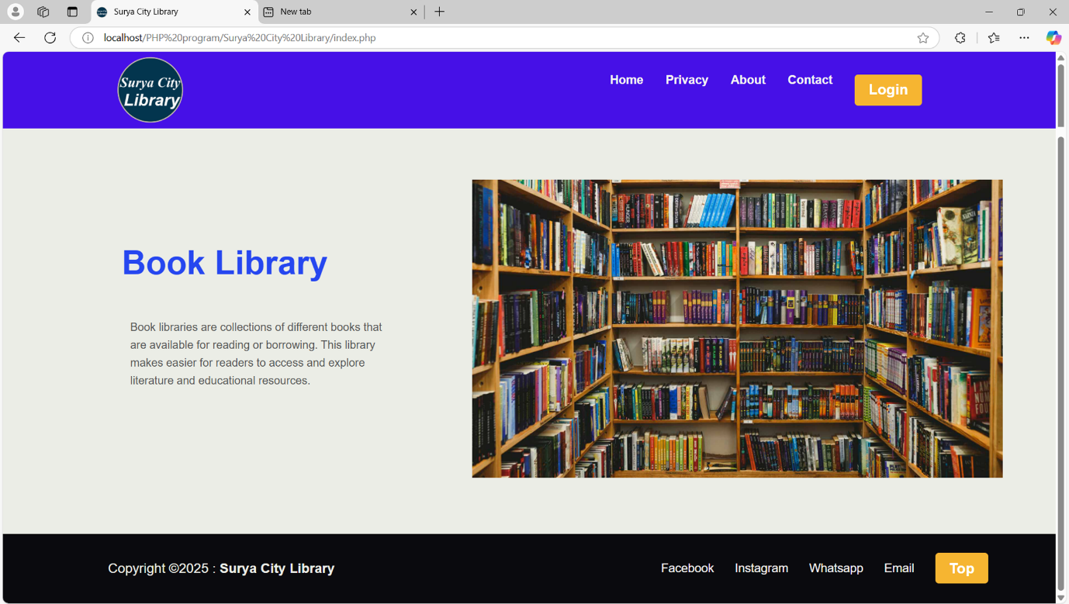

**Student Login**

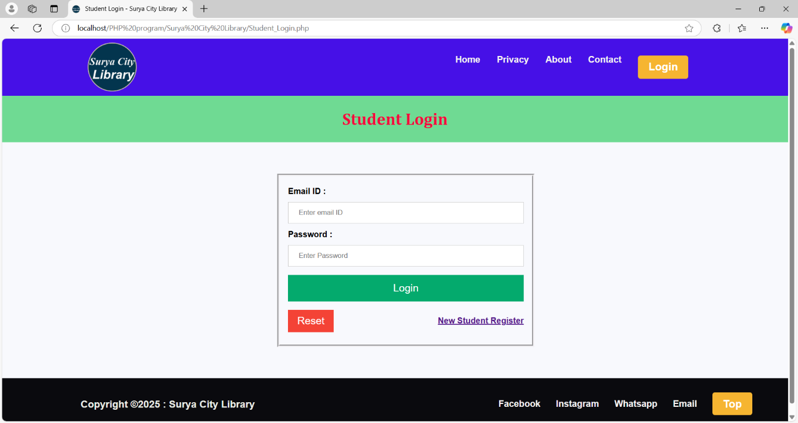

**Student Registration**

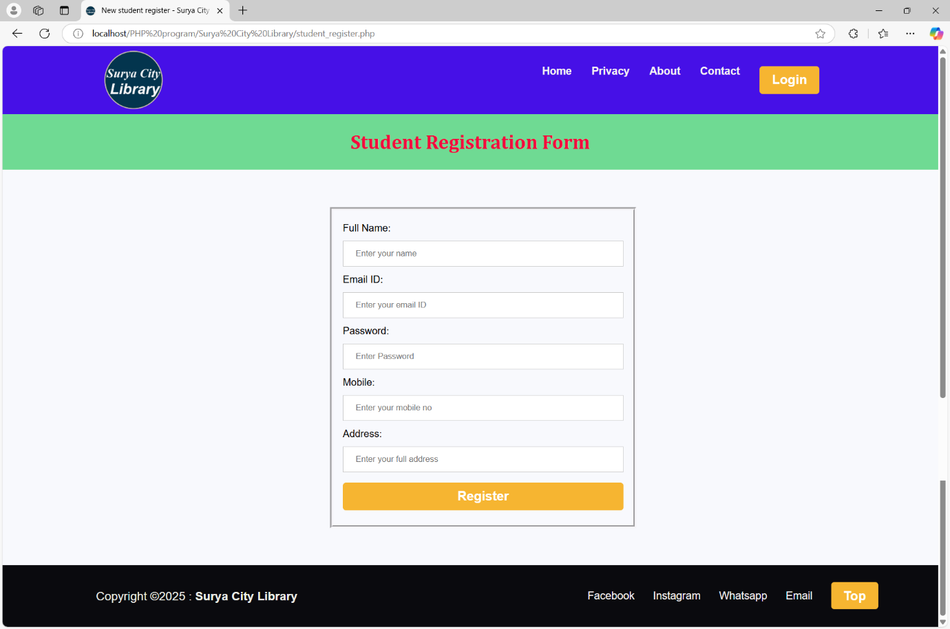

**User Dashboard**

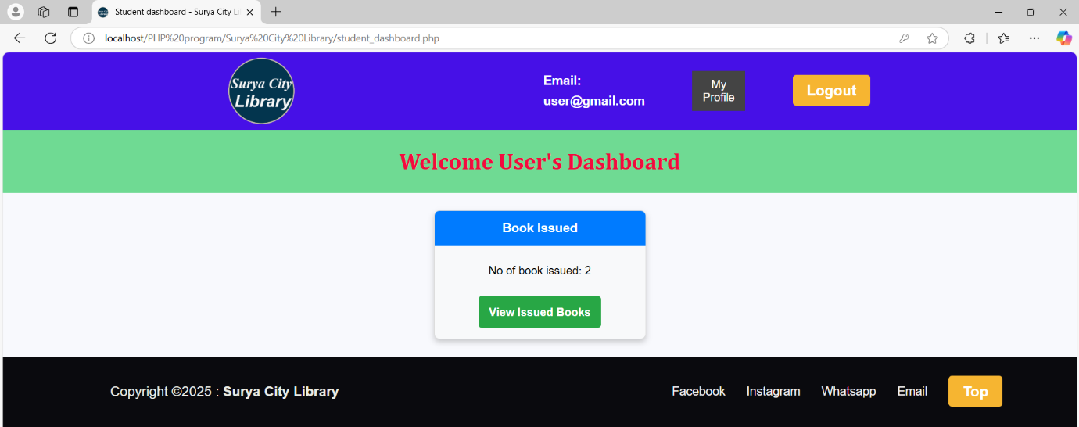

**Issued Books**

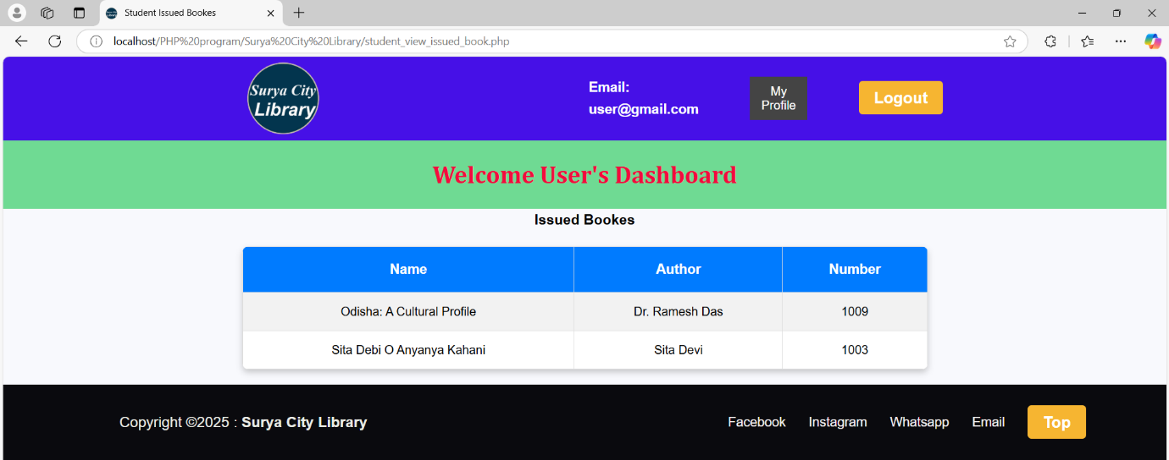

**Admin Login**

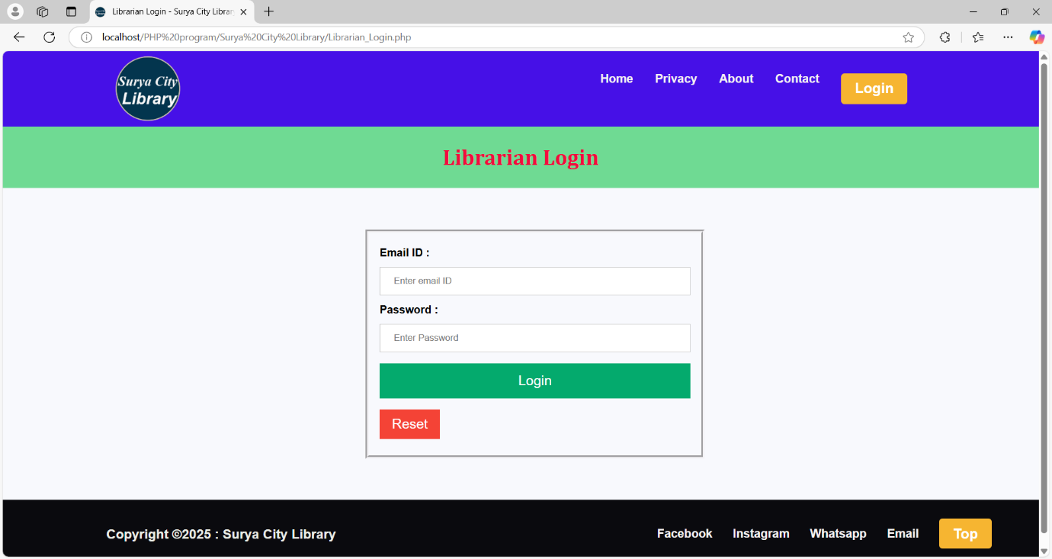

**Admin Dashboard**

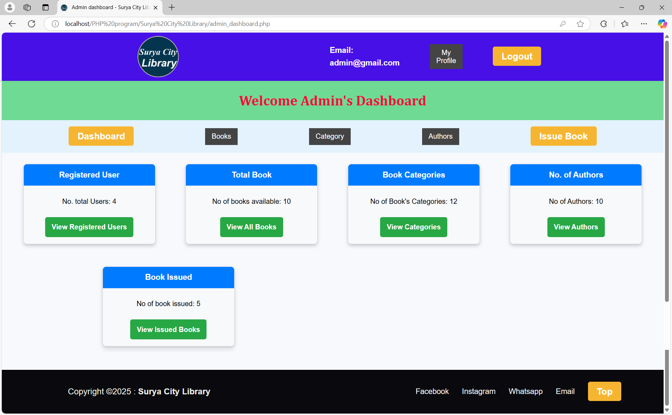

**Admin Profile**

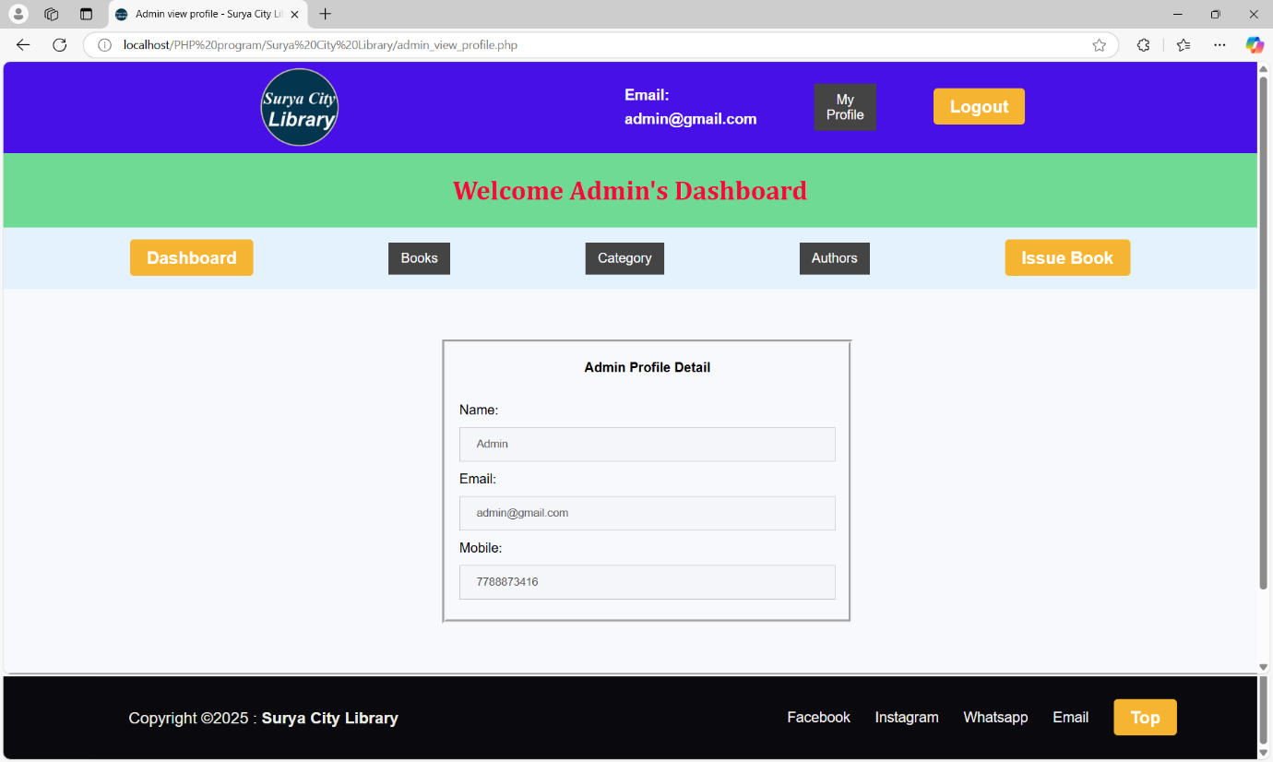

**Add new book**

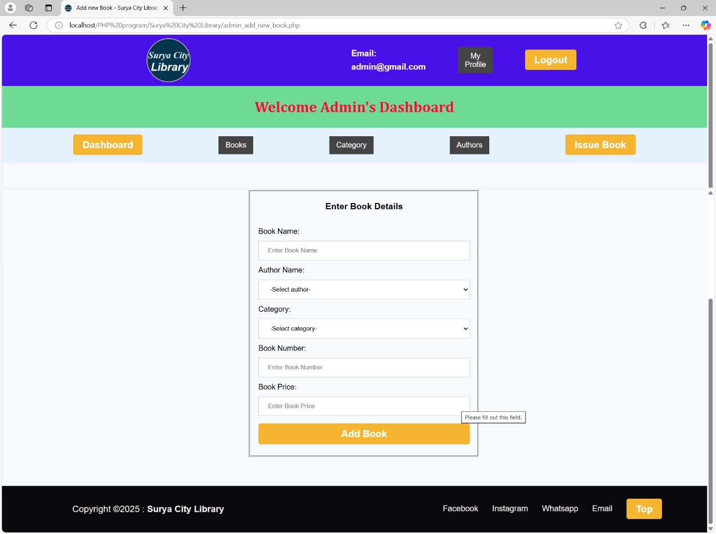

**Issue Book**

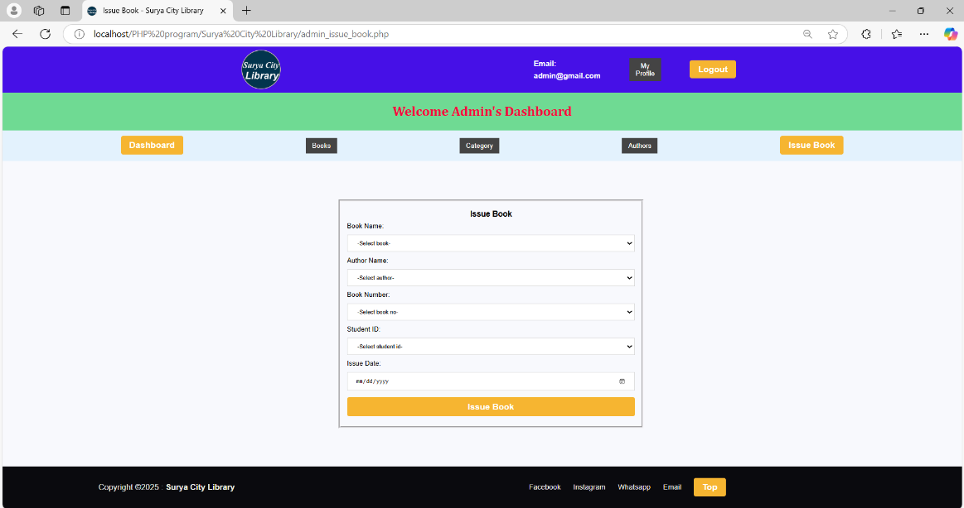

**Issued Books**

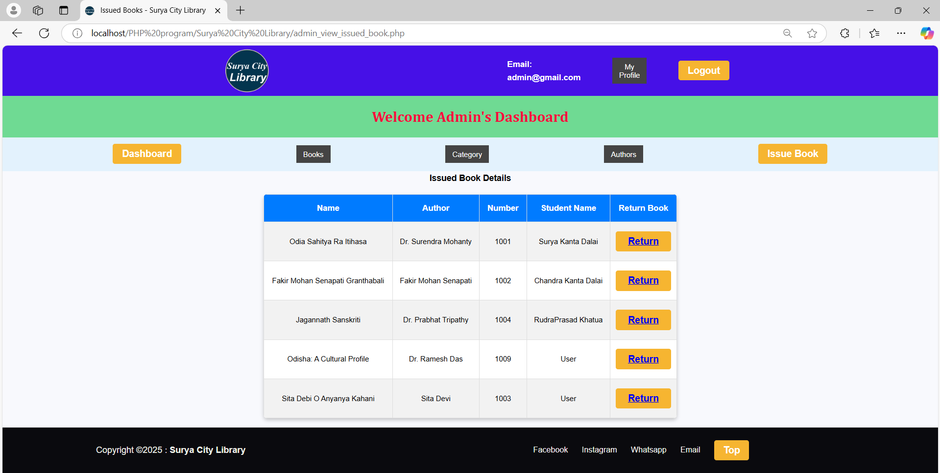

1. **IMPLEMENTATION AND TESTING**

This phase involves converting the system design into a working application and validating its functionality through testing. The implementation process includes choosing the right approach, coding, and deploying the system, while testing ensures the system is error-free and meets the requirements.

* + 1. **IMPLEMENTATION APPROACHES**

The implementation of the Library Management System (LMS) can follow different approaches depending on the project scope and technology stack.

**Modular Implementation**

* The system is developed in separate modules (User Management, Book Management, Issue/Return, etc.).
* Each module is tested individually before integration.
* Ensures faster development and debugging.

**Incremental Development**

* The system is built in stages, with basic features implemented first.
* Advanced features (e.g., notifications, reports, fine calculation) are added gradually.
* Allows early testing and feedback.

**Full System Implementation**

* The entire system is developed and tested before deployment.
* Suitable for small-scale projects with limited functionalities.

**Deployment Strategy**

* **Local Deployment**: Testing and running the system on local machines.
* **Cloud Deployment:** Hosting the system on cloud services (AWS, Azure, Firebase).
* **Server Deployment**: Deploying on an organization’s internal server.
  + 1. **TESTING APPROACH**

The testing phase ensures that the system functions correctly and meets the requirements. The testing approach consists of:

**Manual Testing**

* Checking basic operations like book issuance, return, and fine calculation.
* Ensuring the UI is user-friendly and functions as expected.

**Automated Testing**

* Using unit tests for functions like searching books, issuing books, and fine calculation.
* Performing integration tests to check the interaction between different modules.

**Testing Levels**

The testing process is divided into:

* **Unit Testing**: Testing individual components.
* **Integrated Testing**: Ensuring modules work together.
* **System Testing**: Validating the entire application.
* **User Acceptance Testing (UAT)**: Testing by end-users to check usability.
  + - 1. **UNIT TESTING**

**Objective:** Test individual modules and functions in isolation to ensure they work correctly.

**Example:**

* Checking if the search function returns correct book details.
* Validating fine calculation logic.

**Expected Outcome:**

* The fine calculation should return the correct amount.
* The search function should return the correct book details.
  + - 1. **INTIGREATED TESTING**

**Objective:** Ensure that different modules interact correctly.

**Example:**

* Verifying that book issuance updates the database and affects availability status.
* Ensuring that fine calculation is triggered correctly when a book is overdue.

**Example Integration Test Scenario:**

| **Test Case** | **Input** | **Expected Output** |
| --- | --- | --- |
| Issue a book | User ID: 101, Book ID: 205 | Book status updated, transaction created |
| Return a book late | Return Date > Due Date | Fine calculated and stored in DB |
| Search for a book | Query: "Python" | List of Python-related books displayed |

**Testing Tools:**

* **Postman** (for API testing if LMS is web-based).
* **Selenium** (for UI testing if it has a web interface).
* **JUnit / PyTest / Mocha** (for backend testing in Java, Python, or JavaScript).

1. **RESULT AND DISCUSSION**

After successful implementation and testing, the Library Management System provides the following results:

**System Functionality**

* **User Management:** Users can register, log in, and manage their accounts.
* **Book Management:** Librarians can add, update, and remove book records efficiently.
* **Issuance & Return System:** The system tracks book borrowing, and returns.
* **Reports & Analytics:** Generates reports on book circulation and user activity.

**Performance Analysis**

* **System Speed:** The system processes book searches, user logins, and transactions in less than 1 second.
* **Database Efficiency:** Optimized queries ensure quick book retrieval and transaction processing.
* **User Experience:** The UI is intuitive, reducing the learning curve for users.

**Testing Outcomes**

| **Test Case** | **Expected Result** | **Actual Result** | **Status** |
| --- | --- | --- | --- |
| User Login | User successfully logs in | Success | Passed |
| Search Book | Returns matching books | Correct books displayed | Passed |
| Issue Book | Book status updated | Status changed to ‘Issued’ | Passed |
| Return Book | Book availability updated | Status changed to ‘Available’ | Passed |
| Fine Calculation | Correct fine calculated | Matches expected fine | Passed |
| Notification System | Due-date reminders sent | Email received | Passed |

**DISCUSSION**

**Impact on Library Operations**

* **Efficiency Boost:** The LMS automates routine tasks, reducing manual errors.
* **Improved Book Accessibility:** The search functionality enables quick book discovery.
* **Time-Saving:** Users spend less time issuing and returning books, improving library workflow.
* **Better Record Management:** The database structure ensures accurate tracking of books and users.

**Challenges Faced**

* **Database Optimization:** Managing a large book database initially caused slower response times, resolved through indexing.
* **User Adoption**: Some users found the transition from manual to digital challenging, requiring training sessions.

1. **CONCLUSION**

The **Library Management System** successfully automates and enhances the efficiency of library operations. It provides a **user-friendly interface** for students, and librarians to manage book borrowing and returns. The system significantly reduces **manual work**, improves **book tracking**, and enhances **user accessibility** through features like **reporting**.

Key benefits of the system include:

* Faster book search and retrieval using optimized database queries.
* Accurate book issuance and return tracking, reducing manual errors.
* Automated fine calculation, ensuring fairness and transparency.
* Efficient user management, providing role-based access for students, librarians, and admins.
* Notification system, sending reminders for due dates and overdue books.

The implementation and testing phases demonstrated **high reliability and accuracy**, ensuring the system meets its functional requirements effectively.

* + 1. **LIMITATIONS OF THE Project**

Despite its success, the **Library Management System** has some limitations:

* **Limited to Institutional Libraries** – The system is primarily designed for schools, colleges, and universities. Public library integration may require additional customization.
* **No Multi-Language Support** – Currently, the system operates in a single language (e.g., English).
* **Requires Internet for Remote Access** – If deployed on a local server, users can only access the system within the institution’s network.
* **Dependency on Manual Data Entry** – Initial book and user data entry require manual effort, which can be time-consuming.
* **No AI-based Recommendations** – The system does not provide book suggestions based on user reading history.
  + 1. **FUTURE SCOPE OF THE PROJECT**

To enhance the **Library Management System**, the following features can be implemented in future versions:

* **Mobile App Development** – Creating an Android/iOS app to allow users to access library services on mobile devices.
* **Cloud-Based System** – Deploying the system on cloud platforms (AWS, Google Cloud) for remote accessibility.
* **AI-Powered Book Recommendations** – Using machine learning to suggest books based on user reading patterns.
* **Barcode/QR Code Scanning** – Automating book check-ins and checkouts using barcode or QR code scanning.
* **Multi-Language Support** – Implementing language options for a wider audience.
* **Voice Search Integration** – Enhancing accessibility by allowing users to search books using voice commands.
* **E-Book Integration** – Adding support for e-books and digital resources for online reading.

These enhancements will make the **Library Management System** more **scalable, efficient, and user-friendly**, benefiting a wider range of libraries and users.

1. **REFERENCES**

The following references were used in the development and documentation of the Library Management System:

* **PHP -** [**PHP Tutorial**](https://www.w3schools.com/php/default.asp)
* **MySQL -** [**MySQL Tutorial**](https://www.w3schools.com/mysql/default.asp)
* **HTML, CSS, JavaScript -** [**W3Schools Online Web Tutorials**](https://www.w3schools.com/)
* **Diagrams -** [**Software Development**](https://www.geeksforgeeks.org/library-management-system/)

1. **GLOSSARY**

This section defines key terms used in the Library Management System project:

* **Backend** – The server-side of the application responsible for database operations and logic processing.
* **Barcode Scanner** – A device used to scan book barcodes for easy check-in and checkout.
* **CRUD (Create, Read, Update, Delete)** – Basic operations performed on a database.
* **Database** – A structured collection of data stored for easy access and management.
* **Frontend** – The user interface (UI) part of the system that interacts with users.
* **Integrated Testing** – A phase in testing where different modules of the system are combined and tested together.
* **Librarian Dashboard** – The control panel used by librarians to manage books, users, and transactions.
* **MySQL** – A relational database management system used to store book and user records.
* **Testing** – The process of evaluating the system to detect and fix bugs or errors.
* **User Roles** – Different levels of access for users.